***Survivable Hybrid***

***Wireless-Optical***

***Broadband-Access Network***

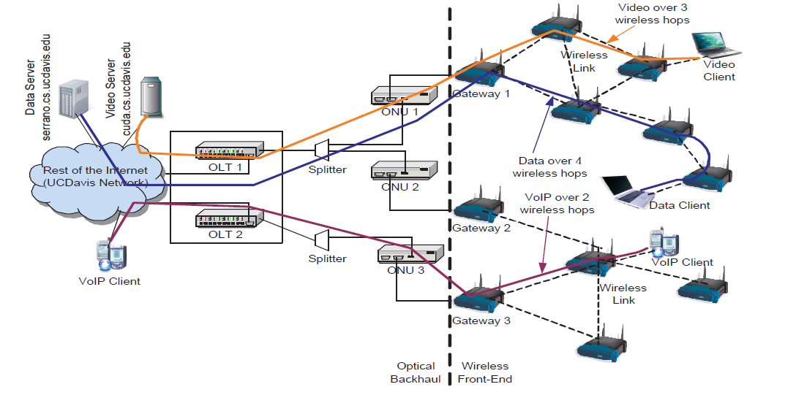

Short report by,

Ferhan Jamal

100953487(Carleton University)

**Table of Contents**

*Abstract*……………………………………………………………………………………….3

1. What is a WOBAN? 4

2. Why WOBAN? 8

3. Survivability of WOBAN 16

3.1 Optical Survivability 16

3.1.1 Link Protection 17

3.1.2 Path Protection 17

3.1.2.1 Link Restoration 18

3.1.2.1 Path Restoration 18

3.1.2.3 Sub-Path Restoration 18

3.2 Wireless Survivability 19

4. Conclusion 20

5. Acknowledgment………………………………………………………………………….21

6. References……………………………………………………………………………….. 21

***Abstract***

*In today’s era, internet has become a promising tool in any company or organization. The new technology which is wireless-optical broadband access network (WOBAN) is now emerging as a promising technology to provide economical and scalable broadband Internet access to the end users. It has solved the problem of bandwidth to an extreme level and will be used by many users in the future. As the name says, it consists of both wireless and optical part which in-turn optimizes the cost and performance of an access network. In this cross-domain network architecture, end-users receive broadband services through a wireless mesh front-end network which is connected to the optical backhaul network via gateway nodes. It is very much economic efficient mainly in the rural areas [7] where the existing wired telecommunication infrastructures such as Cabled Modem, Digital Subscriber Line (DSL), T-1/E-1 networks, or fiber deployments are either very expensive or not reachable to the users. It is very much reliable in extreme weather conditions by providing “weather survivable links” pushing the high bandwidth backbone access network towards the distribution access point. It is also called passive optical network as it uses fiber and passive components like splitters and combiners rather than active components like amplifiers, repeaters, etc.*

*Wireless Optical Broadband Access Networks (WOBAN) is a promising architecture for access networks. In this report, I will discuss the survivability of both the wireless and the optical parts of the Wireless Optical Broadband Access Network and discuss the ways how the survivability can be achieved if any of the component gets failed in the wireless and the optical part of the Wireless Optical Broadband Access Network. I will also discuss the various advantages and disadvantages of Wireless Optical Broadband Access Network which eventually have attracted the researchers to get evolved more in this area.*

**1. What is WOBAN ?**

WOBAN stands for wireless optical broadband access network. As the name signifies, it consists of both wireless and optical parts. The architecture diagrams of WOBAN are as follows:

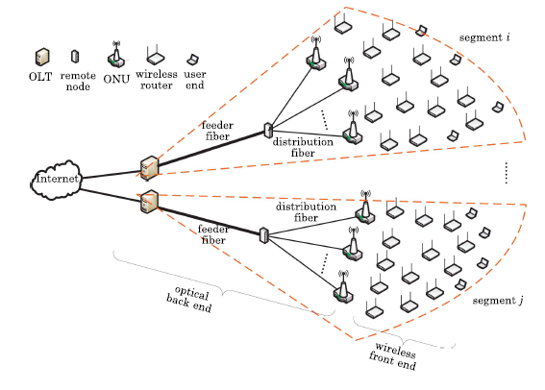

Fig. 1 WOBAN Architecture Diagram

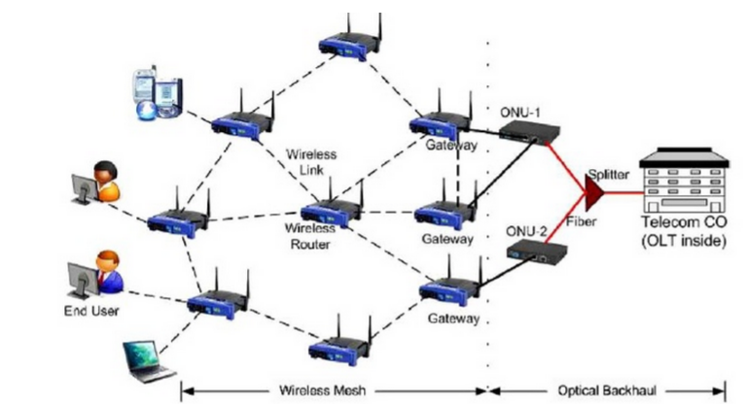

Fig. 2 WOBAN Architecture Diagram

The major components used in WOBAN are OLT, ONU, Optical Splitter, Router, Clients, etc. The technology is expected to provide a data rate of 125Mbps-1.25Gbps to end users than other alternatives such as DSL and cable networks which are not able to carry the high volume of traffic generated by emerging applications such as video-on-demand interactive gaming, or duplex video conferencing. **It is a point-to-multipoint network consisting of a single transceiver in the OLT in the central office (CO). The OLT sends information to the ONU’s located at the subscriber end of the network.**

WOBAN’s are usually connected in a way [3] that the telecom central office consisting of OLT can control several ONUs (Optical Network Units), and each ONU can drive several wireless routers of wireless front end in WOBAN. The wireless routers directly connected to the ONUs are called wireless gateways. The wireless front-end also consists of other wireless routers to provide end-user connectivity. Therefore the front end of the WOBAN is effectively a multi-hop Wireless Mesh Network which is connected to the high capacity PON segment in the back end, creating a cross-domain integrated network architecture.

**The PON (WOBAN) follows time division multiplexing [8] terminology in which a single wavelength is used for all downstream transmissions and another wavelength is used for all upstream transmissions. The upstream bandwidth is shared among the users in the manner of TDM.**

The following table [3] shows the WOBAN components with their specifications:

|  |  |
| --- | --- |
| **Components** | **Interface/Port** |
| **OLT** | * **Client Side: One EPON Port** * **Network Side: One 100/1000 Base-T Ethernet port (for ROI (Rest of the Internet))** |
| **ONU** | * **Client Side: Two 10/100 Base-T**   **Ethernet ports (to drive 802.11g**  **routers)**   * **Network Side: One EPON port**   **(to connect OLT)** |
| **Optical Splitter** | **1:8 Power Splitter** |
| **802.11g Router** | * **Client Side: One radio port** * **Network Side: 10/100 Base-T**   **Ethernet port** |
| **Clients** | * **Laptops, PDAs, etc.** |

By seeing the table, the components used in Wireless Optical Broadband Access Network are OLT (Optical Line Terminal), ONU (Optical Network Unit), Optical Splitter, 802.11g Router, Clients, etc. The basic functions of each of the components are as follows:

**Optical Line Terminal (OLT):** An optical line terminal (OLT) is the endpoint hardware device in a passive optical network (PON). It controls all the things in Wireless Optical Broadband Access Network. Optical Line Terminal is located at the end point of a Wireless Optical Broadband Access Network and it also end-point hardware device in a passive optical network. The primary functions of Optical Line Terminal are as follows:

a. It is used in converting between electrical signals generated by the service provider equipment and the fibre optical signals in passive optical network.

b. It is also used for coordinating the multiplexing between the conversions devices on the Optical Network Terminals located on the customer’s premises.

The general look of Optical Line Terminal is as follows:

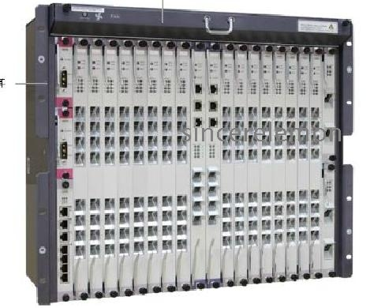

Fig.3 Optical Line Terminal

**Optical Network Unit (ONU):** It is the point which terminates the optical network which can be connected to various users. The basic function of Optical Network unit is as follows:

a. It converts optical signals which are transmitted through fiber to electrical signals.

b. The converted electrical signals are then sent to the subscribers/users.

It is used with OLT and it gives the users/subscribers with many different kinds of broadband services such as VoIP, HDTV, and videoconferences. It is very much economical and highly efficient equipment and play a vital role in the FTTx fiber optic network. The general diagram of Optical Network Unit is shown below

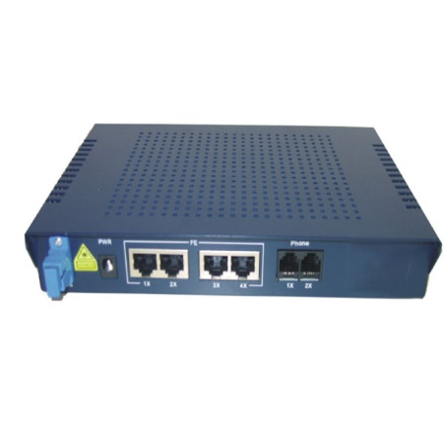

Fig.4 Optical Network Unit

**Optical Splitter:** It is a very important device in passive optical network (PON) systems, also known as a passive optical splitter, which splits the optical signal power evenly into all the output ports. The features of optical splitter are as follows:-

a. It splits fiber into two or many destinations.

b. No power is required in the optical splitter as there are no electrical parts in it.

c. Low cost in comparison active distribution amplifiers.

d. Basic connectors used are Neutrik Optical CON, -LC, -SC, -ST

The general diagram of optical splitter is as follows:

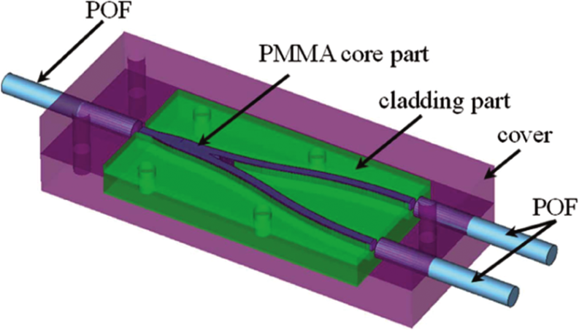

Fig.5 Optical Splitter

**Routers:** A router is a device that is connected to two or more networks that allows data packets to forward from one network to another. Router works on the network layer 3 of the OSI model. The shortest path in the network is usually used to transfer packets by the router. The sample diagram of a router connecting networks is shown below:

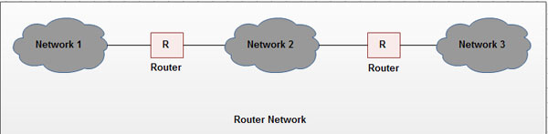

Fig.6 Router Network

The general diagram of router is shown below:

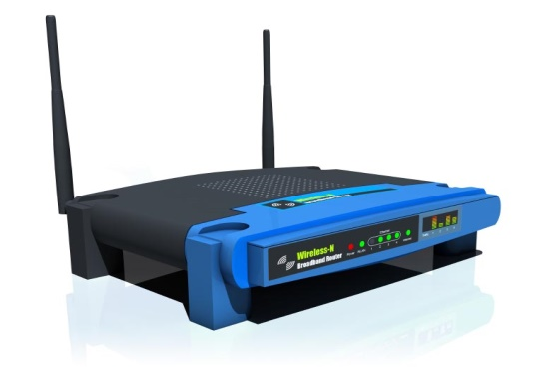

Fig.7 Router

**Clients:** The clients used in the wireless optical broadband access network are basically the laptops and the PDA’s.The client devices are basically PC’s with network software like web-browsers, chat applications, email software, etc. that accesses service made available by a server. Clients rely on servers for getting the resources such as files, devices, bandwidth, etc. The example of a client server network is as follows:

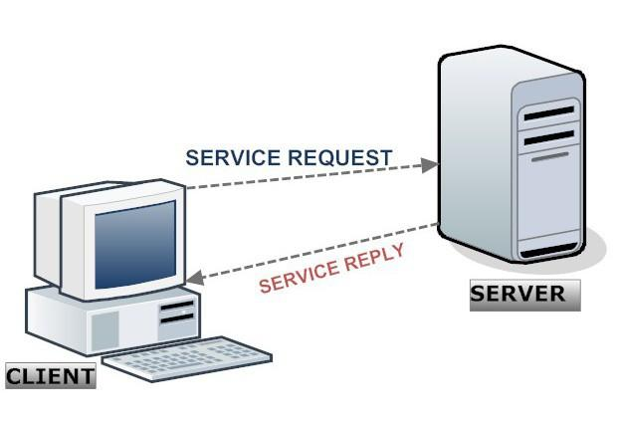

Fig. 8 Client-Server Network

Each of the components as discussed above play a major role in defining a Wireless Optical Broadband Access Network. In the remainder of this report, I will the importance of Wireless Optical Broadband Access Networks, their advantages and disadvantages, and their survivability.

**2. Why WOBAN ?**

As explained above, WOBAN consists of both wireless and optical parts which means it consists of both wired and wireless media.

Wired media has a dedicated physical connection between two devices which means it will have better connectivity and reliability. On the other hand, in wireless connection, there is no physical connection required between two devices in order to establish a network. The advantages of using wired media network and wireless media network are as follows:

**Advantages (Wired Media):**

**1.** In it, the **security** is very high as it not easy to access them without authorization

**2.** The **reliability** of the network is very high as you get a constant download and upload speed from the network without any interference from the environment. The constant speed is possible in this kind of network because in it the signals travel in a wire so there is no chance of interference in the signals from any kind of wireless devices.

**3.** It is very **easy to use** as its get connected by just plugging the cable into the computer instead of scanning for available networks, entering the security keys and looking for an area for strong wifi-signals.

**4.** It can cover 3000 feet or more than that without any loss of quality.

**Advantages (Wireless Media):**

1. It is **cheaper than wired network** as it requires no physical connection in the network.

2. The **network mobility is very high** as we can access the internet anywhere outside the normal work environment. Most coffee shops, restaurants, hotels, shopping centers, airports, etc. provide internet at a very little or no cost.

3. The **network setup is very easy** as it requires very few access points to install it in comparison to the wired network where you have to pull the cables through walls and ceilings to get in connection with the network.

4. **The network expandability** is very high in wireless network. In it many users can access the network as the same time in comparison to the wired network where additional users would require additional wiring

The best solution will be to merge the both together by seeing the advantages of a wired and wireless network. The optical fiber wired network can act as a backbone of the network as they are very robust, less expensive, and provide high amount of bandwidths where wireless network can be used at a front end of the network. As explained above, WOBAN consists of OLT, ONU, Optical Splitter, Router and Clients. After combining the two, the **various advantages of Wireless Optical Broadband Access Network are as follows**:

**a. Cost effectiveness:** As explained above, WOBAN consists of both wireless and optical parts. The cost required for setting up a wireless connection is comparatively less than the cost required for setting up the optical network connection (wired connection) in a network which in-turn makes the whole network as cost-effective.

**b. Reliability:** Integrated wireless optical broadband access network is very much reliable as compare to wireless network or wired network. The problem of congestion and information lost in the WOBAN is not that much as compared to the current wired or wireless network. Both the optical and the wireless comes up with a lot of backup facility in the network therefore the failure in a cable or in a router will not be able to damage the whole network as they have a lot of backup routers or cables available in the network.

Now-a-days, Ethernet manufactures are manufactures are producing the extremely reliable Ethernet cables, hubs and switches. Loose cables remain the basic concern for wired network therefore while installing the wired network, the cable connections must be carefully checked in a network. Broadband routers have also matured over the past several years and their reliability has improved significantly.

**c. Bandwidth:** Thebandwidth provided by the WOBAN is very much high in Gbps as compare to the traditional wired or wireless network. As it consists of both wired and wireless network, the bandwidth produce by the WOBAN is significantly in the range of Tbps or more than that depending upon what type of WOBAN we are using.

Optical fibers by definition transmit light signals through a glass or plastic medium. Optical signals used in the optical network operate at a very high frequency, many orders of magnitude higher than the electromagnetic waves. These systems are very much higher in bandwidth with the capability of operating in Mbps. The combination of both i.e. wired and wireless network will be the best solution to gain more bandwidth than the traditional wired or wireless network as the network will have the high-capacity optical trunk at the back end.

**d. Flexibility:** The front end of the WOBAN consists of the wireless network which passes signals directly to the users at the front end. As discussed above, wireless does not have required any wired connection between the devices therefore it is more flexible than any other network. Users in it are not locked up in a fixed cable network having the flexibility of moving anywhere in wifi signal area. Thus, WiFi i.e. the wireless network will be the suitable technology at the front end of the WOBAN network.

To conclude, WOBAN technology will be the best technology for achieving a significant amount of bandwidth having wireless part at the front end of the network and the optical part i.e. wired media at the back end. The wired media is in the WOBAN is also called the **last mile of the telecommunication network.** It is called as last mile because that part directly reaches the customers. By definition, last mile is a term used by the telecommunications network and internet companies to refer the final leg of the telecommunication network. In WOBAN, the final leg of the telecommunication network is wired media which is called as last mile in the WOBAN. Sometimes, the term first word mile is also used by the telecommunications industries and internet companies to specify the first leg of the telecommunication network. In the WOBAN network, the first mile term can be applied to the users when they are sending or uploading data to the internet.

**3. Survivability of WOBAN**

Survivability has been the major issue in wireless optical broadband access network. The term survivability basically means the capacity of a system or component to withstand the disaster or hostile environment. The WOBAN basically consists of:

1. Wireless part (Wireless Media)
2. Optical part (Wired Media)

The survivability of individual part i.e. both wireless part and optical part need to be discussed carefully in order to understand the survivability of the whole network.

***3.1Survivability (Optical part):***

Optical part carries a lot of wires and cables in their network. The failure in one of the wire or cable will affect the working of whole wireless optical broadband access network. The methods developed for gaining survivability of the optical parts [6] are as follows:

1. **Protection scheme**

* Link Protection
* Path Protection

1. **Restoration scheme**

* Link Restoration
* Path Restoration
* Sub-path Restoration

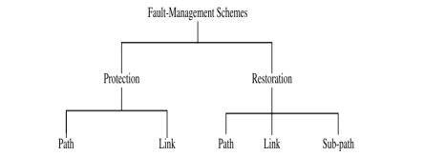

Fig. 9 Fault Management Schemes

In the protection scheme, the link or path are protected in the network by some backup paths or links. The protection scheme which is link protection and path protection as discussed below are commonly used by the wired media companies to protect their network from any kind of failure in the network. The explanation of link protection scheme and path protection scheme are as follows:

*3.1.1 Link Protection Scheme:* In link protection scheme [6], backup paths and wavelength are reserved around each link while setting up the connection. The backup path will activate if the primary link gets failed for some reasons on the network. In link protection scheme, the source and destination nodes of the connections traversing the failed link will be unaffected by it.

*3.1.2 Path Protection Scheme:*In path protection scheme [6], backup paths are reserved on end-to-end basis during connection setup. When a link fails, the source node and destination node passing through the failed link are informed about the failure which in-turn activate the backup path and all the resources around that backup path are utilized.

The 2nd way of having the survivability in the optical part is by using the restoration scheme. In the restoration scheme, we choose the backup path depending upon the type of failure, amount of failure and many other factors. The restoration schemes used by various network designers are as follows:

*3.1.2.1 Link Restoration scheme:*In link restoration scheme [6], the end nodes i.e. the source node and destination node participate in a distributed algorithm to dynamically calculate the new link around that failed link. As soon as the new route is discovered around the failed link, the end nodes around that failed link reconfigure their OXC’s to redirect the traffic that channel onto a new route or path. If in case, no new route can be discovered around a failed link then the connection will get dropped automatically.

*3.1.2.2 Path Restoration scheme:*In path restoration scheme [6], the end nodes i.e. source and destination nodes independently discover a backup path on an end-to-end basis around the failed link of the network. The backup path discovered here can be on a different wavelength channel. In this scheme similar to link restoration scheme the end nodes around that failed link reconfigure their OXC’s to redirect the traffic that channel onto a new route or path. If in case, no new route can be discovered around a failed link then the connection will get dropped automatically.

*3.1.2.3 Sub-Path Restoration scheme:*In sub-path restoration scheme [6] unlike link restoration scheme and path restoration scheme, the upstream node (the node which is closer to the internet backbone) of the failed link discovers a backup path by itself to the destination node for every disrupted or unsettle connection of the network. In this scheme similar to link restoration scheme the end nodes around that failed link reconfigure their OXC’s to redirect the traffic that channel onto a new route or path. If in case, no new route can be discovered around a failed link then the connection will get dropped automatically.

***3.2Survivability (Wireless part)****:*

The wireless part of wireless optical broadband access network carries a lot of routers, gateways, client devices, etc. The failure in one of the devices will have a direct impact to the end users as the end users are very close to wireless part of the Wireless Optical Broadband Access Network. The interference problem in the server and in the wifi signals can also be one of the reasons for failure in the wireless network. The survivability methods basically used for making wireless network survivable are as follows:

**Establish primary (working) and secondary (backup) paths:**  The primary path and back paths are calculated for each node in the wireless mesh network using the shortest path principle. These paths are calculated under no interference conditions. The backup path around the failed link will get activated when there is any kind of failure in the primary path of the network.

**Avoid Risk Groups:** Risk groups basically means whentwo or more nodes in the network share a single common fiber. The nodes basically are here the gateways and the routers which share a single fiber in the network. The failure of fiber in this case will lead to non-working of all the nodes as they are connected directly through it. In other words, risk groups are those group of nodes that are susceptible to failure in the network.

**Assignment of frequency for working and backup paths:** Another way to avoid the failure in the wireless network of Wireless Optical Broadband Access Network is to assign the frequencies to primary and backup paths of the network so that primary and backup links does not fail at the same time. Frequency assignment to primary and backup paths has been the most successful method for achieving the survivability in the wireless network.

To conclude, the survivability in the wireless part of the WOBAN has been a major concern in every type of WOBAN. The above discussed methods are the most discussed methods for the achieving the survivability in the wireless part of WOBAN.

**4. Conclusion**

In this report; I have tried to cover various aspects of Wireless Optical Broadband Access Networks like survivability, their features, reliability, etc. This high bandwidth future access network technology is envisioned to satisfy future bandwidth demand of technology-oriented users by supporting a huge volume of multimedia traffic in a cost-effective way, and it can be attractive solution to future last mile access networks.

A lot of research has been done till now regarding the survivability of Wireless Optical Broadband Access Network. As discussed in the report, the optical part survivability is achieved by link protection schemes and restoration schemes which is then classified as link protection scheme, path protection scheme and link restoration scheme, path restoration scheme, sub-path restoration scheme.

**5. Acknowledgement**

I acknowledge and thank the supervision of Professor Hussein Mouftah and the support of University of Ottawa and Carleton University.

**6. References**

[1] S. H Mohammada, N. Zulkiflia and S. M. Idrus, “A Review of Integrated Optical and Wireless Broadband Access Networks”, Jurnal Teknologi

[2] Lei Guo, Yejun Liu, Fanzhao Wang, Weigang Hou, and Bo Gong, “Cluster-Based Protection for Survivable Fiber-Wireless Access Networks”, J. OPT. COMMUN. NETW./VOL. 5, NO. 11/NOVEMBER 2013

[3] Pulak Chowdhury, Suman Sarkar, Glen Kramer, Sudhir Dixit, and Biswanath Mukherjee, “Hybrid Wireless-Optical Broadband Access Network (WOBAN): Prototype Development and Research Challenges”

[4] N. Correia, J. Coimbra, and G. Schütz, “Fault-Tolerance Planning in Multiradio Hybrid Wireless–Optical Broadband Access Networks”, VOL. 1, NO. 7/DECEMBER 2009/ J. OPT. COMMUN. NETW.

[5] Neeraj Mohan, Amit Wason and Parvinder S. Sandhu, “Trends in Survivability Techniques of Optical Networks”, International Journal of Computer Science and Electronics Engineering (IJCSEE) Volume 1, Issue 2 (2013) ISSN 2320–401X (Print)

[6] Himanshi Saini and Amit Kumar Garg, ”Protection and Restoration Schemes in Optical Networks: A Comprehensive Survey”, Volume 2, No.1, January – February 2013 International Journal of Microwaves Applications

[7] N.Moradpoor, G. Parr, S.McClean, B. Scotney, G. Owusu, “ Hybrid Optical and Wireless Technology Integrations for Next generations Broadband Access Networks”, IEEE International Workshop on Broadband Convergence Networks, 2011.

[8] Taiming Feng and Lu Ruan, “Design of a Survivable Hybrid Wireless Optical Broadband Access Network”, J. OPT. COMMUN. NETW. VOL . 3, NO. 5 MAY 2011